

**Green University of Bangladesh**

**Department of Computer Science and Engineering(CSE)**

**Faculty of Sciences and Engineering**

**Semester: (Spring , Year:2024), B.Sc. in CSE (Day)**

**LAB REPORT NO #04**

**Course Title: Computer Networking Lab**

**Course Code: CSE - 312 Section: 213_D5**

**Lab Experiment Name: Configuration of NAT.**

**Student Details**

| **Name** | | **ID** |
| --- | --- | --- |
|  | **MD Dulal Hossain** | **213902116** |

**Lab Date** **: 23– 05 - 2024**

**Submission Date** **: 29– 05 - 2024**

**Course Teacher’s Name : MS. Rusmita Halim Chaity**

**[For Teachers use only: Don’t Write Anything inside this box]**

| **Lab Report Status**  **Marks: ………………………………… Signature:.....................**  **Comments:.............................................. Date:..............................** |
| --- |

**1. TITLE OF THE LAB EXPERIMENT**

The purpose of this exercise is to configure NAT on the source router (NAT

inside source) and test for connec-tivity by pinging a remote router.

**2. OBJECTIVES/AIM**

To configure NAT on network devices to facilitate seamless communication

between internal and external networks while conserving public IP addresses.

**3. PROCEDURE / ANALYSIS / DESIGN**

1. Assign IP addresses on all the devices as per the above table

2. Enable routing on all routers (you can use RIP/EIGRP/OSPF routing)

3. Create IP NAT Mapping (Hint: use inside source static command) on R1

4. Define IP NAT Inside and IP NAT Outside on R1

5. Test for Connectivity from PC1 to R2 by issuing ping command

**4. IMPLEMENTATION**

**4.1 IP Configuration**

Configure static IP addresses on the PC’s and Router.

Click the device and go to the Desktop tab > IP Configuration.

1. For PC 1: Set 192.168.1.10 IP , 255.255.0.0 Subnet Mask & Gateway 192.168.1.1 (Figure 1).

2. For PC 2: Set 192.168.1.11 IP , 255.255.0.0 Subnet Mask & Gateway 192.168.1.1 .

3. For PC 3: Set 10.1.1.10 as IP address , 255.0.0.0 as Subnet Mask & Gateway is 10.1.1.1 .

4. For PC 4: Set 10.1.1.10 as IP address , 255.0.0.0 as Subnet Mask & Gateway is 10.1.1.1 .

5. For Router 2 :

1. First Ethernet 192.168.1.1 as IP address and 255.255.255.0 Subnet Mask (Figure 2).
2. For serial 0/0/0: Set 200.200.200.1 IP and 255.255.255.0 as Subnet Mask . Also Clock Rate 64000. (Figure 3).

6. For Router 3 :

1. First Ethernet set 10.0.0.1 as IP address and 255.0.0.0 as Subnet Mask .
2. For serial 0/1/0: Set 200.200.200.2 as IP address and 255.255.255.0 as Subnet Mask.Also Clock Rate 64000.

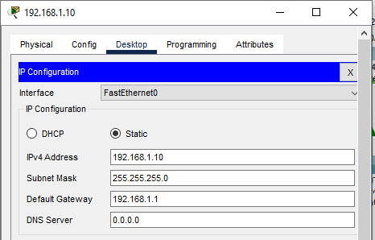

Figure 1 : IP configure PC 1

| Figure 2 : IP configureFastEthernet0/0. | Figure 3 : IP configure Serial 0/0/0. |
| --- | --- |

**4.2 Routing**

**Configure NAT :**

| **Router 2 :** | **Router 3 :** |
| --- | --- |
| Router#en  Router#conf t  Enter configuration commands, one per line. End with CNTL/Z.  Router(config)#ip nat inside source static 192.168.1.10 200.200.200.10  Router(config)#interface FastEthernet 0/0  Router(config-if)#ip nat inside  Router(config-if)#exit  Router(config)#interface Serial 0/0/0  Router(config-if)#ip nat outside  Router(config-if)#exit  Router(config)#exit (Figure 4). | Router#en  Router#conf t  Enter configuration commands, one per line. End with CNTL/Z.  Router(config)#ip nat inside source static 192.168.1.11 200.200.200.11  Router(config)#interface FastEthernet 0/0  Router(config-if)#ip nat inside  Router(config-if)#exit  Router(config)#interface Serial 0/0/0  Router(config-if)#ip nat outside  Router(config-if)#exit  Router(config)#exit |

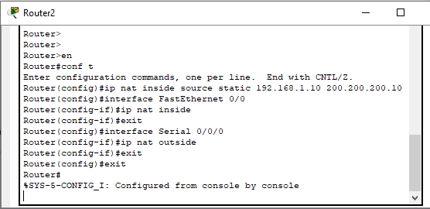

Figure 4 : Configure NAT.

**Dynamic or RIP :**

For Router 2 : Add the network address like 10.0.0.0 , 200.200.200.0 (Figure 5).

For Router 3 : Add the network address like 192.168.1.0, 200.200.200.0

**Static :**

For Router 2 : Add the network address like 192.168.1.0 via 200.200.200.2 (Figure 6).

For Router 3 : Add the network address like 10.1.1.0 via 200.200.200.1 .

| Figure 5 : Dynamic or RIP Routing. | Figure 6 : Static Routing. |
| --- | --- |

**5. TEST RESULT / OUTPUT**

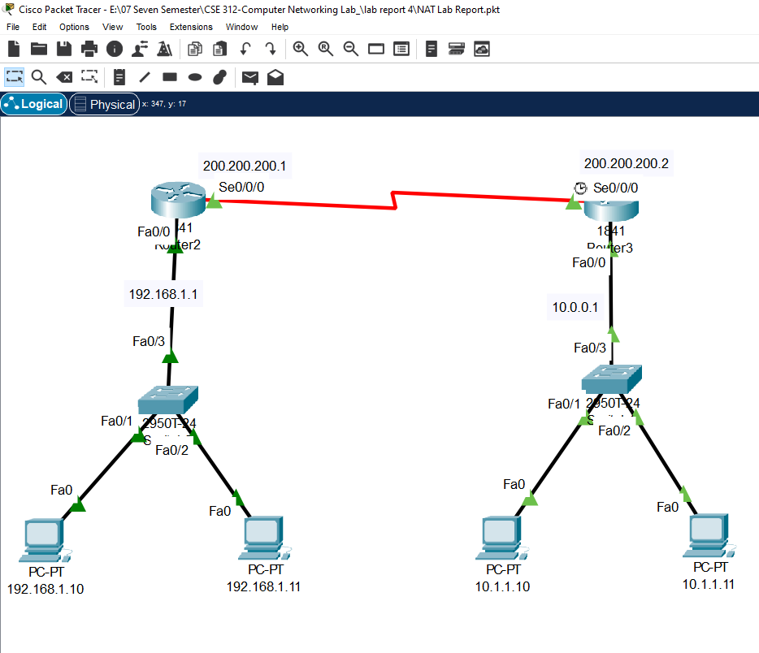

Figure 7 : A network Check Static NAT & Dynamic NAT.

**5.1 Static Test**

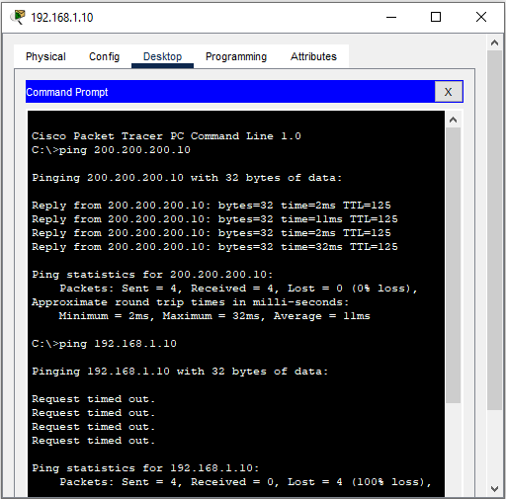

Figure 8 : Static NAT successfully Run.

**5.2 Dynamic or RIP Test**

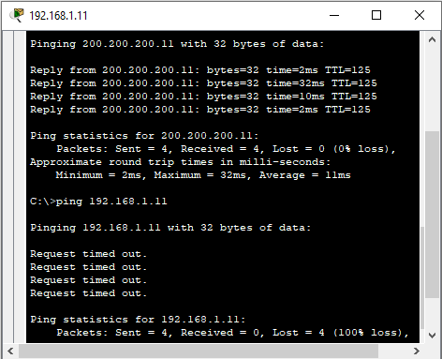

Figure 9 : Dynamic or RIP NAT successfully Run.

**6. ANALYSIS AND DISCUSSION**

In this lab, we successfully configured static NAT to facilitate communication between internal and external networks. By mapping inside local IP addresses to inside global IP addresses, we enabled seamless interaction between devices across different networks, conserving public IP addresses in the process. The hands-on practice with Cisco Packet Tracer reinforced the theoretical concepts of NAT, such as inside and outside addresses and the distinctions between static, dynamic, and PAT. The successful ping tests confirmed that the static NAT setup was correctly implemented, ensuring secure and efficient network communication. This exercise enhanced our understanding and confidence in configuring NAT on network deviceSo we say that our lab report work 100% properly.